Social Network Analysis Using a Graph Database

Exercise 1 — Display the Complete User Network
MATCH (u:User)-[r:FRIEND]->(f:User)
RETURN u, r, f;

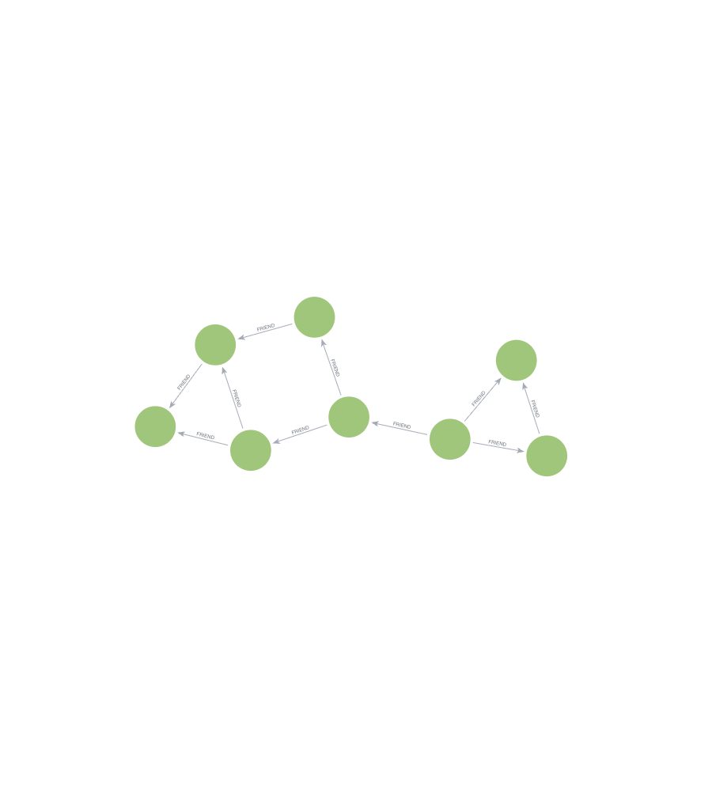

Exercise 2 — Display Only Friendships
MATCH (u:User)-[r:FRIEND]->(f:User)
RETURN u, r, f;

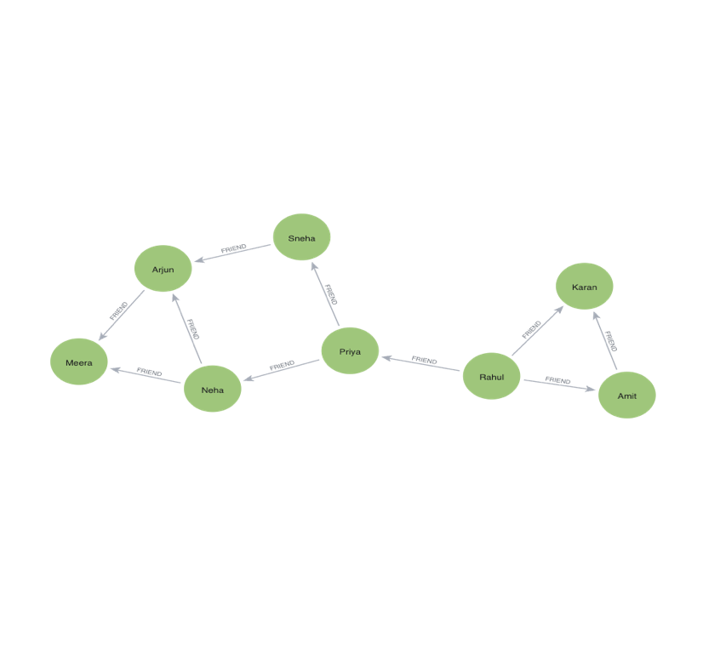

Exercise 3 — Rahul's Immediate Network
MATCH (r:User {name:'Rahul'})-[f:FRIEND]-(friend:User)
RETURN r, f, friend;

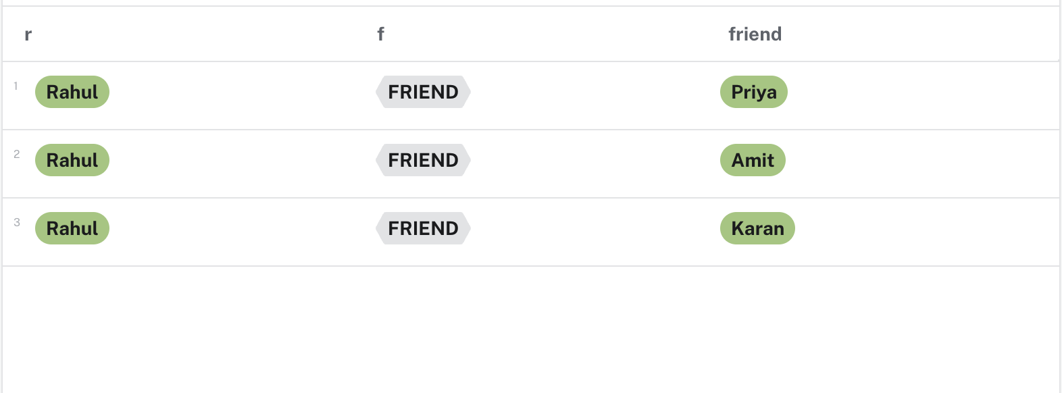

Exercise 4 — Rahul's Friends-of-Friends
MATCH (r:User {name:'Rahul'})-[:FRIEND*2]-(fof:User)
WHERE fof <> r
RETURN DISTINCT fof.name AS FriendOfFriend;

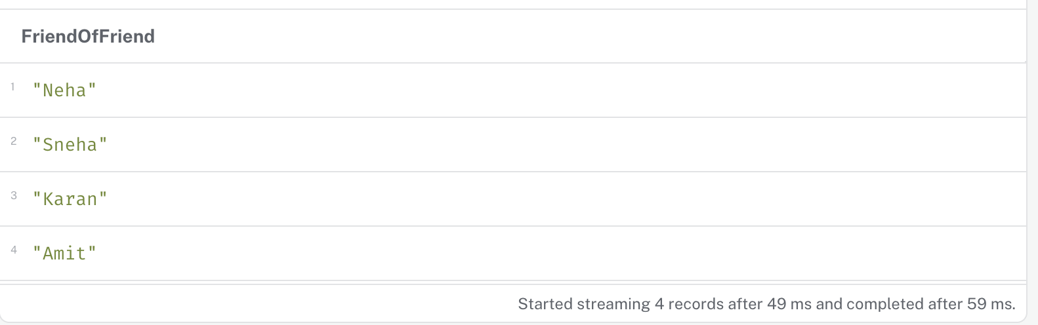

Exercise 5 — One to Three Hops
MATCH path=(r:User {name:'Rahul'})-[:FRIEND*1..3]-(u:User)
WHERE u <> r
RETURN path;

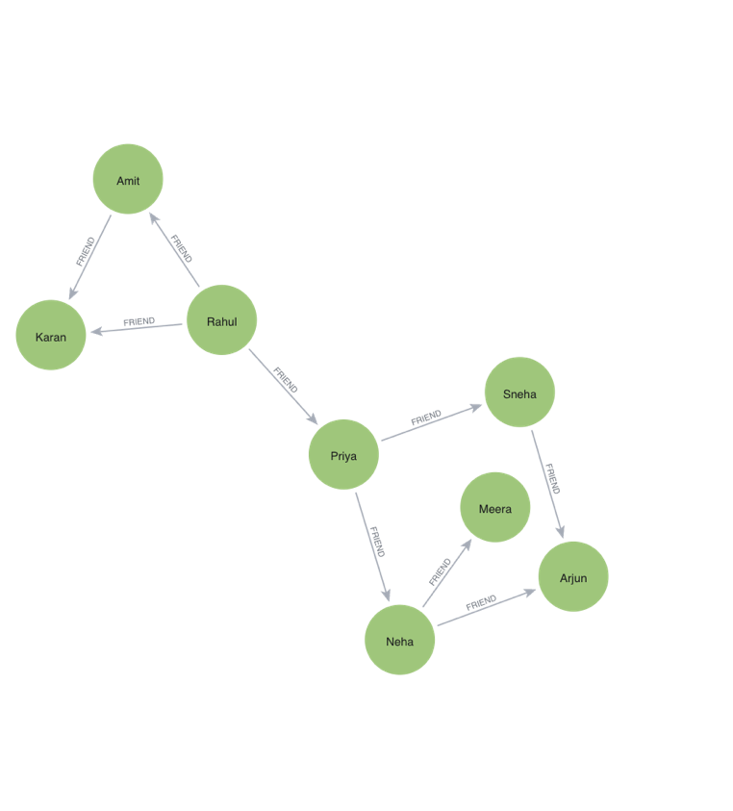

Exercise 6 — Connection Between Rahul and Karan
MATCH path=
(r:User {name:'Rahul'})-[:FRIEND*1..5]-(k:User {name:'Karan'})
RETURN path;

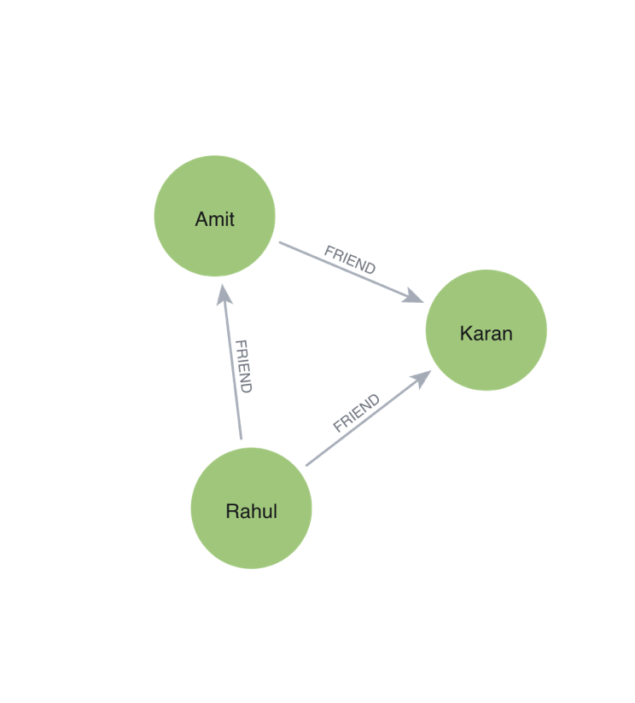

Exercise 7 — Shortest Social Connection (Any user)
MATCH path=
(a:User)-[:FRIEND*1..10]-(b:User)
WHERE a <> b
RETURN a.name AS User1,
b.name AS User2,
length(path) AS Distance,
path
ORDER BY Distance ASC
LIMIT 1;

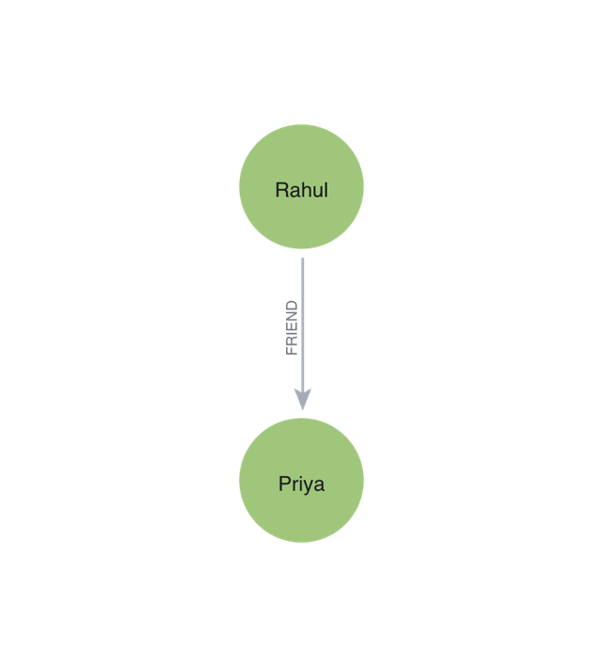

Exercise 8 — Longest Social Connection
MATCH path=
(a:User)-[:FRIEND*1..10]-(b:User)
WHERE a <> b
RETURN a.name AS User1,
b.name AS User2,
length(path) AS Distance,
path
ORDER BY Distance DESC
LIMIT 1;

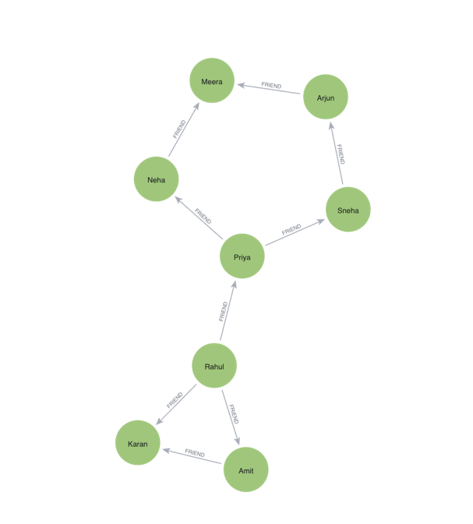

Exercise 9 — Users and Groups
MATCH (u:User)-[r:MEMBER_OF]->(g:Group)
RETURN u, r, g;

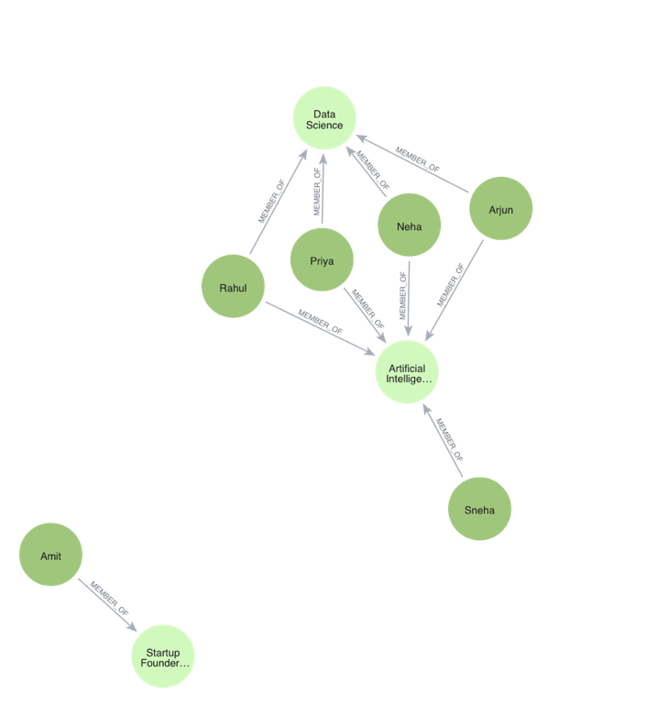

Exercise 10 — Users and Their Comments
MATCH (u:User)-[r:COMMENTED]->(c:Comment)
RETURN u.name AS User,
c.id AS CommentID,
c.text AS Comment,
c.sentiment AS Sentiment,
c.likes AS Likes;

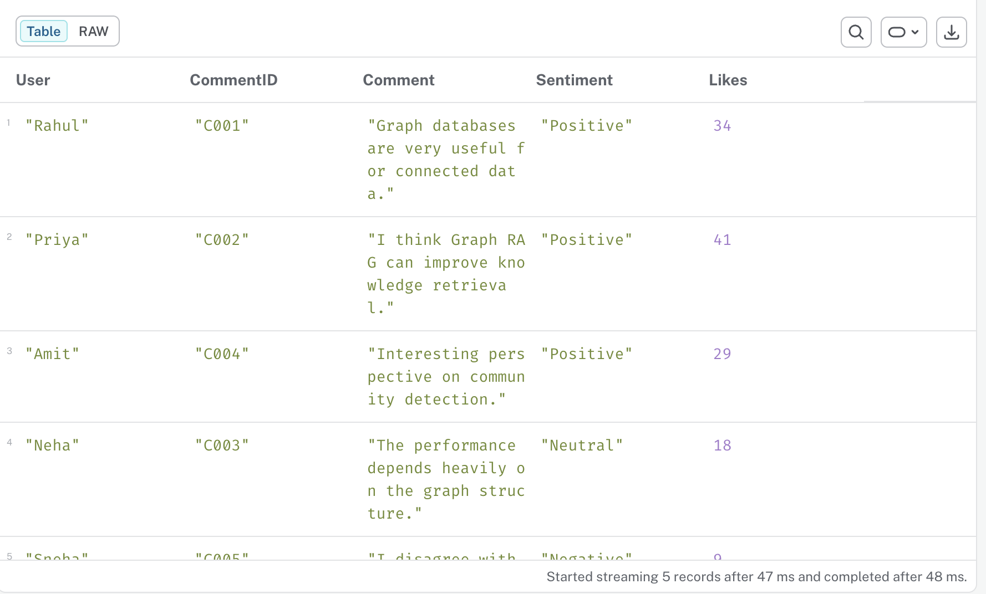

Exercise 11 — Comment Conversation Network
MATCH (u:User)-[r:REPLIED_TO]->(c:Comment)
RETURN u, r, c;

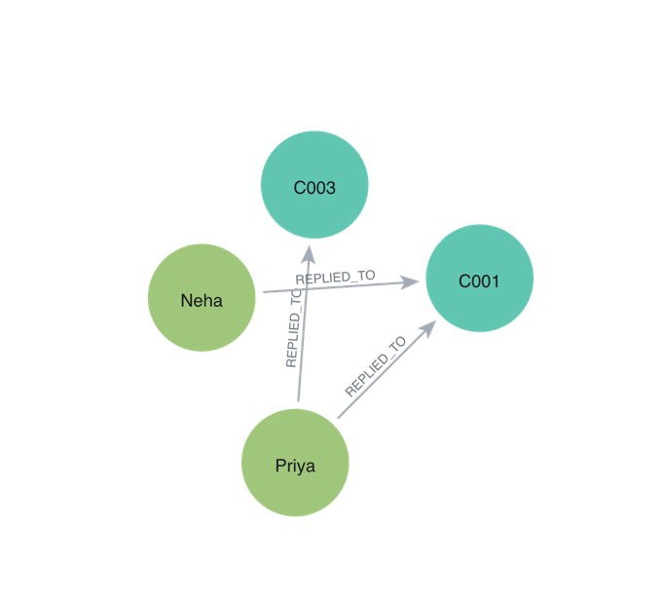

Exercise 12 — Users, Comments and Topics
MATCH (u:User)-[:COMMENTED]->(c:Comment)-[:ABOUT]->(t:Topic)
RETURN u, c, t;

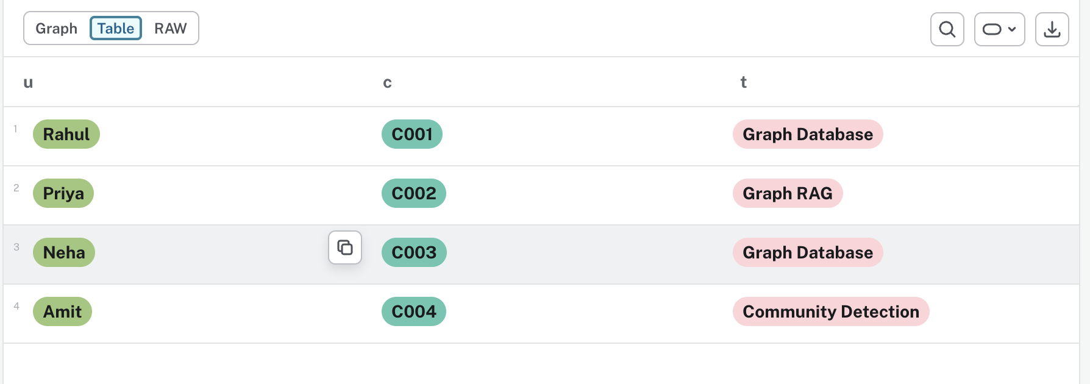

Exercise 13 — Shared Topic Network
MATCH (u1:User)-[:COMMENTED]->(c1:Comment)-[:ABOUT]->(t:Topic)<-[:ABOUT]-(c2:Comment)<-[:COMMENTED]-(u2:User)
WHERE u1 <> u2
RETURN u1, t, u2;

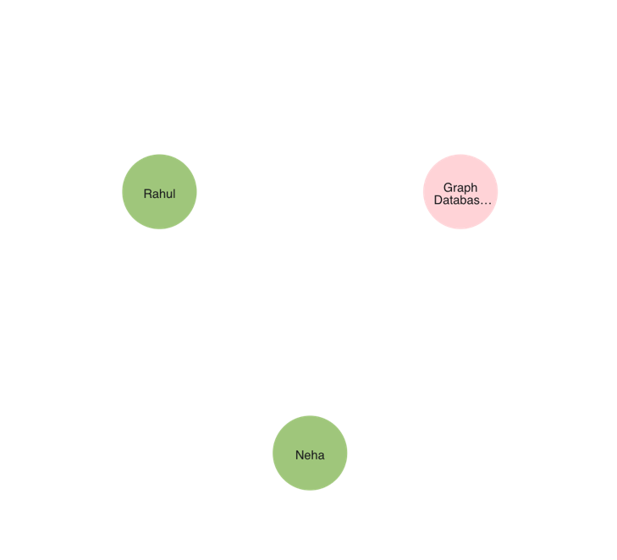

Exercise 14 — High-Toxicity Interaction
MATCH (u:User)-[:COMMENTED]->(c:Comment)
WHERE c.toxicity > 0.10
OPTIONAL MATCH (reply:User)-[:REPLIED_TO]->(c)
RETURN c.id AS CommentID,
u.name AS CommentedBy,
c.toxicity AS Toxicity,
reply.name AS RepliedBy;

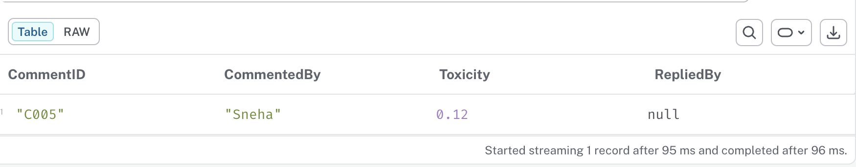

Exercise 15 — Friend Recommendation Graph
MATCH (r:User {name:'Rahul'})-[f1:FRIEND]-(mutual:User)-[f2:FRIEND]-(candidate:User)
WHERE candidate <> r
AND NOT (r)-[:FRIEND]-(candidate)
RETURN r, f1, mutual, f2, candidate;

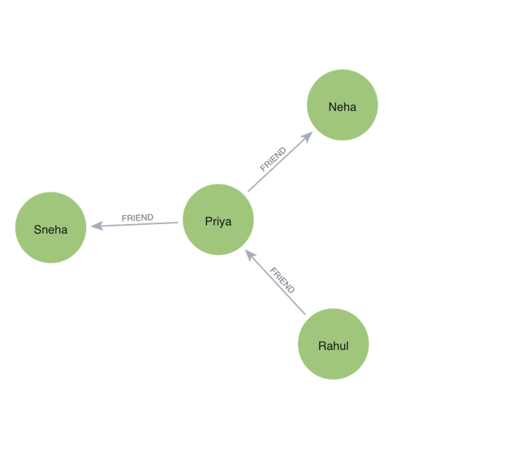

Exercise 16 — Complete Social Interaction Graph
MATCH (a)-[r]->(b)
RETURN a, r, b;

